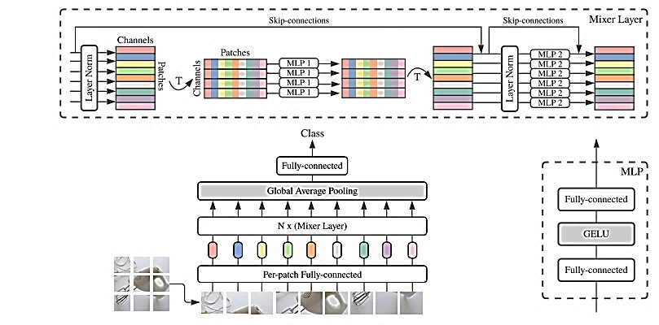
Figure 3.4 Structural diagram of the MLP-Mixer network
Note. Reprinted from MLP-Mixer: An all-MLP architecture for vision, by T. Toker, G. Gordon, Y. Tay, et al. (2021), in Advances in Neural Information Processing Systems (Vol. 34, pp. 11733–11744)

